24 June 2003 4032 Immediate

Car production on track for strong 2003
Production figures released today by the Office for National Statistics show that:

▲Output for the export markets rose three per cent for the year-to-date
▼Output for home market fell 27.9 per cent
▼Car production in May slowed 15.9 per cent

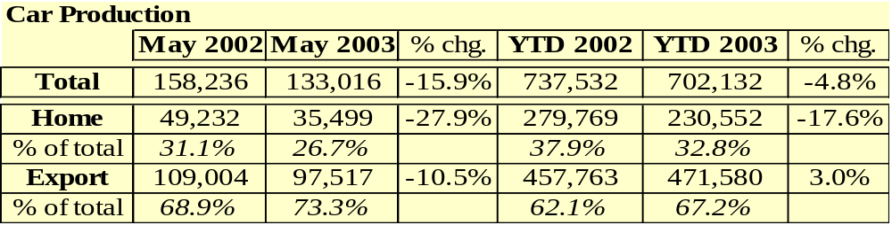
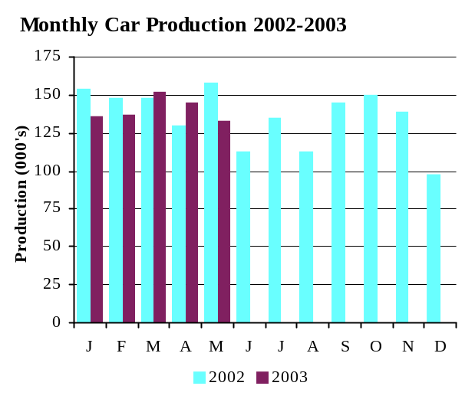

- Car production for 2003 is expected to rise in the second half of the year to exceed 1.63 million units, up on 2002's figure.
- UK production slipped 15.9 per cent from a strong 2002 position when output rose by 24.4 per cent. The 2003 figure remains 4.4 per cent up on May 2001's production figure.

Commenting on the new data, SMMT chief executive Christopher Macgowan said, 'UK car production reported its first decline in the past three months as output failed to match the high level reached in 2002. Exports dipped for the first time this year, but remain positive over the year-to-date. We believe that car production in the UK will recover and are fully expecting year-end volumes to better 2002's 1,628,020 units'.

CV output for UK market up 11.6 per cent

Provisional output data released today by the Office for National Statistics show that:

▲Output for the home market grew for the third consecutive month
▼Output for the export market slipped 24.8 per cent
▼CV production in May 2003 cooled by 11.4 per cent

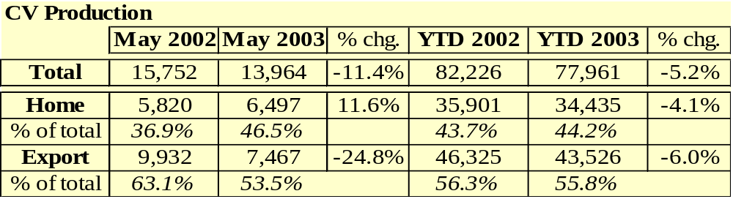

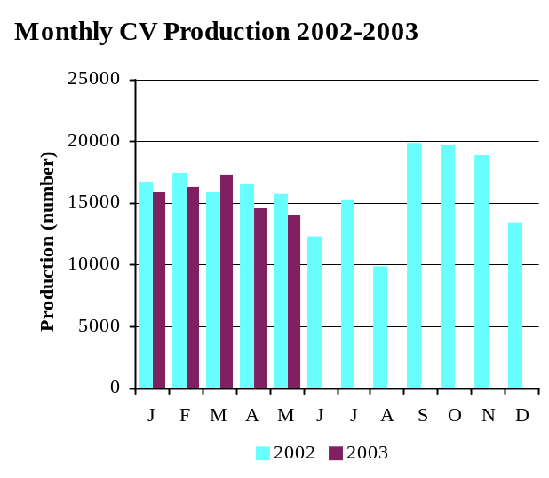
- Output for the home market grew for the third successive month, up 11.6 per cent month on month.

- Year-to date CV production remained strong, easing by 5.2 per cent despite an 11.4 per cent dip in May's figures.

Commenting on the provisional figures, SMMT chief executive Christopher Macgowan said, 'It is very encouraging to see CV output for the home market rise for the third successive month. While the demand for commercial vehicles has eased across the rest of Europe, the buoyant domestic market is maintaining a steady level for UK production. We remain confident that full year volumes will be on a par with 2002 levels.'

PASSENGER CARS COMMERCIAL VEHICLES
 |  | Total | For Home | For Export | Total | For Home | For Export
1993 a |  | 1 375 524 | 842 648 | 532 876 | 193 467 | 102 320 | 91 147
1994 |  | 1 466 823 | 848 142 | 618 681 | 227 815 | 132 270 | 95 545
1995 |  | 1 532 084 | 787 473 | 744 611 | 233 011 | 140 634 | 92 377
1996 |  | 1 686 134 | 777 922 | 908 212 | 238 314 | 125 830 | 112 484
1997 |  | 1 698 001 | 736 090 | 961 911 | 237 706 | 134 304 | 103 402
1998 |  | 1 748 258 | 727 531 | 1 020 727 | 227 379 | 124 538 | 102 841
1999 |  | 1 786 623 | 648 146 | 1 138 477 | 185 905 | 110 983 | 74 922
2000 |  | 1 641 452 | 578 462 | 1 062 990 | 172 442 | 96 261 | 76 181
2001 |  | 1 492 365 | 598 111 | 894 254 | 192 873 | 96 654 | 96 219
2002 |  | 1 628 020 | 581 212 | 1 046 808 | 191 315 | 77 087 | 114 228
2000 Q1 |  | 494 311 | 179 401 | 314 910 | 49 972 | 24 666 | 25 306
2000 Q2 |  | 433 240 | 140 548 | 292 692 | 52 061 | 27 345 | 24 716
2000 Q3 |  | 335 106 | 145 558 | 189 548 | 29 249 | 18 588 | 10 661
2000 Q4 |  | 378 795 | 112 955 | 265 840 | 41 160 | 25 662 | 15 498
2001 Q1 |  | 387 100 | 160 646 | 226 454 | 51 623 | 31 952 | 19 671
2001 Q2 |  | 372 395 | 142 864 | 229 531 | 49 675 | 26 436 | 23 239
2001 Q3 |  | 335 790 | 152 753 | 183 037 | 43 347 | 21 032 | 22 315
2001 Q4 |  | 397 080 | 141 848 | 255 232 | 48 228 | 17 234 | 30 994
2002 Q1 |  | 449 755 | 194 579 | 255 176 | 49 940 | 24 630 | 25 310
2002 Q2 |  | 400 529 | 119 032 | 281 497 | 44 504 | 16 226 | 28 278
2002 Q3 |  | 391 850 | 149 633 | 242 217 | 44 900 | 18 966 | 27 934
2002 Q4 |  | 385 886 | 117 968 | 267 918 | 51 971 | 19 265 | 32 706
2003 Q1 |  | 431 199 | 152 878 | 278 321 | 49 196 | 21 181 | 28 015
2001 Jan |  | 128 921 | 50 675 | 78 246 | 17 580 | 11 315 | 6 265
2001 Feb |  | 124 163 | 55 434 | 68 729 | 16 290 | 10 085 | 6 205
2001 Mar |  | 134 016 | 54 537 | 79 479 | 17 753 | 10 552 | 7 201
2001 Apr |  | 112 547 | 45 865 | 66 682 | 14 172 | 8 097 | 6 075
2001 May |  | 127 176 | 46 614 | 80 562 | 15 563 | 8 418 | 7 145
2001 Jun |  | 132 672 | 50 385 | 82 287 | 19 940 | 9 921 | 10 019
2001 Jul |  | 114 878 | 50 943 | 63 935 | 14 055 | 6 427 | 7 628
2001 Aug |  | 89 350 | 43 180 | 45 540 | 11 960 | 5 994 | 5 966
2001 Sep |  | 131 562 | 58 000 | 73 562 | 17 332 | 8 611 | 8 721
2001 Oct |  | 145 984 | 53 206 | 92 778 | 17 607 | 6 697 | 10 910
2001 Nov |  | 144 989 | 51 841 | 93 148 | 17 588 | 6 051 | 11 537
2001 Dec |  | 106 107 | 36 801 | 69 306 | 13 033 | 4 486 | 8 547
2002 Jan |  | 154 368 | 69 454 | 84 914 | 16 697 | 8 280 | 8 417
2002 Feb |  | 147 552 | 65 707 | 81 845 | 17 389 | 10 016 | 7 373
2002 Mar |  | 147 835 | 59 418 | 88 417 | 15 854 | 6 334 | 9 520
2002 Apr |  | 129 541 | 35 958 | 93 583 | 16 534 | 5 451 | 11 083
2002 May |  | 158 236 | 49 232 | 109 004 | 15 752 | 5 820 | 9 932
2002 Jun |  | 112 752 | 33 842 | 78 910 | 12 218 | 4 955 | 7 263
2002 Jul |  | 134 549 | 49 685 | 84 864 | 15 217 | 5 323 | 9 894
2002 Aug |  | 112 803 | 45 771 | 67 032 | 9 793 | 3 704 | 6 089
2002 Sep |  | 144 498 | 54 177 | 90 321 | 19 890 | 7 939 | 11 951
2002 Oct |  | 149 654 | 51 672 | 97 982 | 19 769 | 7 259 | 12 510
2002 Nov |  | 138 765 | 40 020 | 98 746 | 18 806 | 7 647 | 11 159
2002 Dec |  | 97 467 | 26 276 | 71 191 | 13 396 | 4 359 | 9 037
2003 Jan |  | 136 101 | 50 926 | 85 175 | 15 818 | 7 484 | 8 334
2003 Feb |  | 136 330 | 50 551 | 85 779 | 16 287 | 7 348 | 8 939
2003 Mar |  | 151 880 | 49 526 | 102 354 | 17 256 | 6 514 | 10 742
2003 Apr |  | 144 805 | 44 050 | 100 755 | 14 636 | 6 592 | 8 044
2003 May |  | 133 016 | 35 499 | 97 517 | 13 964 | 6 497 | 7 467
Percentage change for latest three months on:
Previous three months | 16.2 |  | 1.0 | 24.2 | 0.8 | 2.1 | -0.2
Same period last year | -1.4 |  | -10.7 | 3.3 | -4.7 | 11.3 | -14.0

a - 5 week month or 14 week quarter or 53 week year Source: Office for National Statistics

